**EXPERIMENT 3**

Write a Servlet program that prints "Hello, World!" when accessed through a browser.

**AIM :**

To create a simple **HTML, CSS, and JavaScript** program that displays the text **"Servlet"**, and changes it to **"Hello, World!"** when a button is clicked.

**ALGORITHM :**

• Start by creating an HTML structure with a head and body section.

• Define CSS styles inside a <style> tag to style the page elements.

• Inside the <body>, add a <p> element with an id="demo" displaying "Servlet".

• Create a <button> element with an onclick event.

• Use JavaScript inside onclick to modify the text content of the <p> tag using document.getElementById().

• Ensure the syntax is correct, especially in the onclick function.

• Save the file as index.html and open it in a web browser.

• Click the button to see the text change dynamically.

**CODE:**

<!DOCTYPE html>

<html lang="en">

<head>

<meta charset="UTF-8">

<meta name="viewport" content="width=device-width, initial-scale=1.0">

<title>Hello, World!</title>

<style>

body {

font-family: Arial, sans-serif;

text-align: center;

margin-top: 100px;

background-color: #f4f4f4;

}

h1 {

color: #333;

}

button {

background-color: #007bff;

color: white;

border: none;

padding: 10px 20px;

font-size: 18px;

cursor: pointer;

border-radius: 5px;

}

button:hover {

background-color: #0056b3;

}

</style>

</head>

<body>

<p id="demo">Servlet</p>

<button onclick='document.getElementById("demo").innerHTML="Hello world!";'>

Reload

</button>

</body>

</html>

**OUTPUT:**

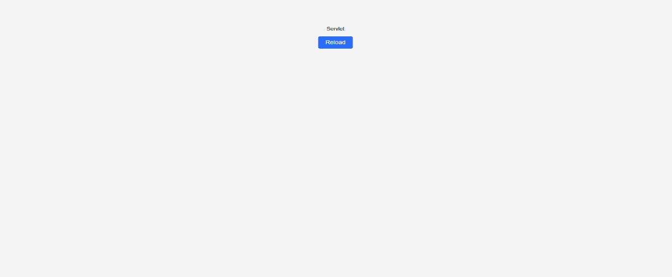

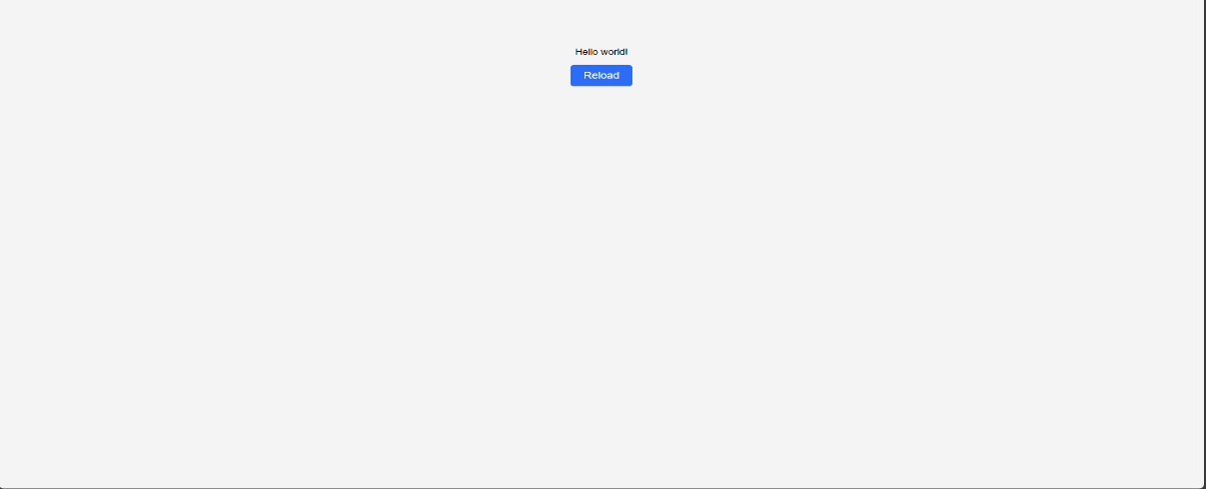

**RESULT :**

Thus the give task is executed successfully.